**Mobile Dispatch Big Picture Directives**

PURPOSE

Provide increased situational and spatial awareness to officers in the field and to streamline communication between the dispatcher and officer.

VISION

Simple, pure, intuitive application that thinks one step ahead for the officer. Keeps them organized and ready for action with the necessary information to best serve the community.

*There are 4 major epics for the 1st spiral of Mobile Dispatch*

1. MAIN MAP DISPLAY

PURPOSE: Immediate spatial and situational awareness for the *officer.* The officer has the ability to survey what is happening around him/her in relation to his/her own location.

1. CHANGE STATUS

PURPOSE: Situational awareness for the *dispatcher*. The *officer* indicates what availability he/she has for dispatch, the dispatcher can then have a better awareness of what their officers are doing and who is available/unavailable.

1. NEW DISPATCH

PURPOSE: To notify an officer of a new assigned dispatch and provide the necessary information in an easy to understand visual representation for him/her.

1. ON SCENE INFO GATHER

PURPOSE: To provide a format for the officer to effectively gather and store information regarding the incident while on scene.

EMPATHY

An officer has a very stressful job. They need to be prepared to react appropriately and effectively to any situation that may arise at any given time. An officer has a responsibility to protect and serve the public.

It’s important that we create a product that enhances the officer’s ability to fulfill that responsibility without becoming a distraction, *or* too complex (ineffective and unusable).

DEFINITIONS:

Officer – An employee of the agency, also referred to as a *unit*.

Unit – Is an *officer*, most of the time associated with a vehicle as well.

On Duty – A status that indicates that the officer is currently working.

Off Duty – A status that indicates that the officer is not working.

Available – An officer who can be dispatched to a call/incident is *available*.

Unavailable – An officer who cannot be dispatched to a call/incident is *unavailable*.

Incident – An event or situation.

Call – A potential event or situation reported to the dispatch center by a person.

Dispatch (noun) – An assignment to the officer.

Dispatch (verb) – When a Dispatcher assigns a Call or Incident to an officer.

Necessary Permission(s) from user device:

* Permission to access Camera
* Permission to access Photos
* Permission to send Notifications **Required (for use of app)**
* Permission to use Location **Required (for use of app)**

SETTING (APP MENU OPTION):

Location Reporting

*Reporting officer/unit location to agency*

This setting is directly tied to the binary status change. When the officer’s status is “On Duty” their location is reported to the agency.

**Always Report Location: On/Off**

An officer can choose to continuously report location

**Selective Off Duty Location Reporting: On/Off**

When this setting is *ON*, the officer should have an opportunity to turn ON location reporting while he is off duty.

MY PROFILE:

**Upload a photo (Crops to circle)**

(Name and Rank are assigned internally in RPS)

EPIC#1 Main Map Display

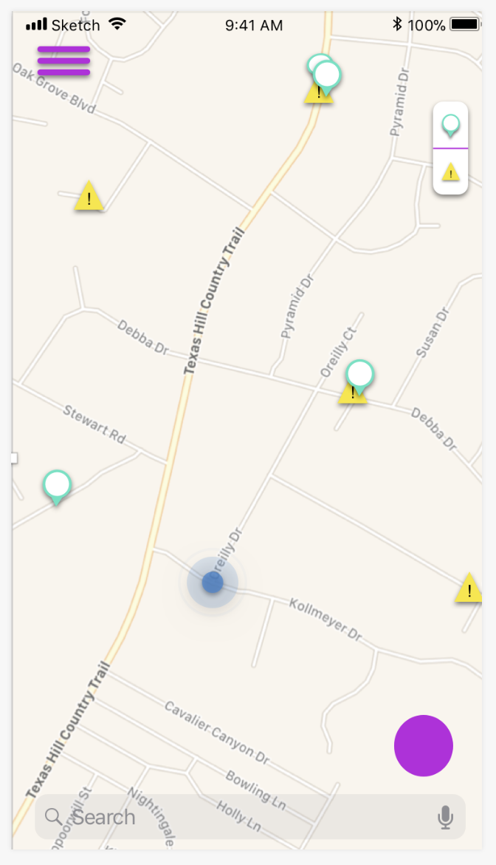 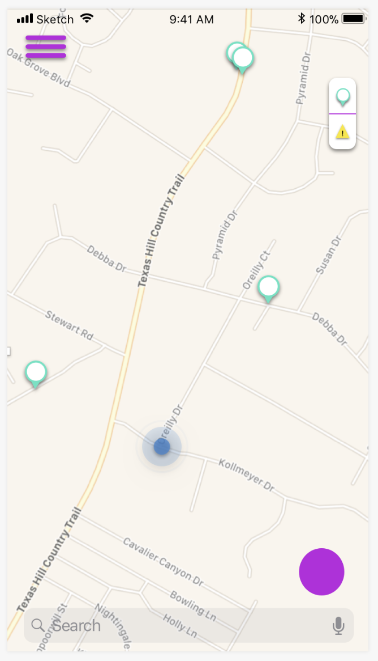 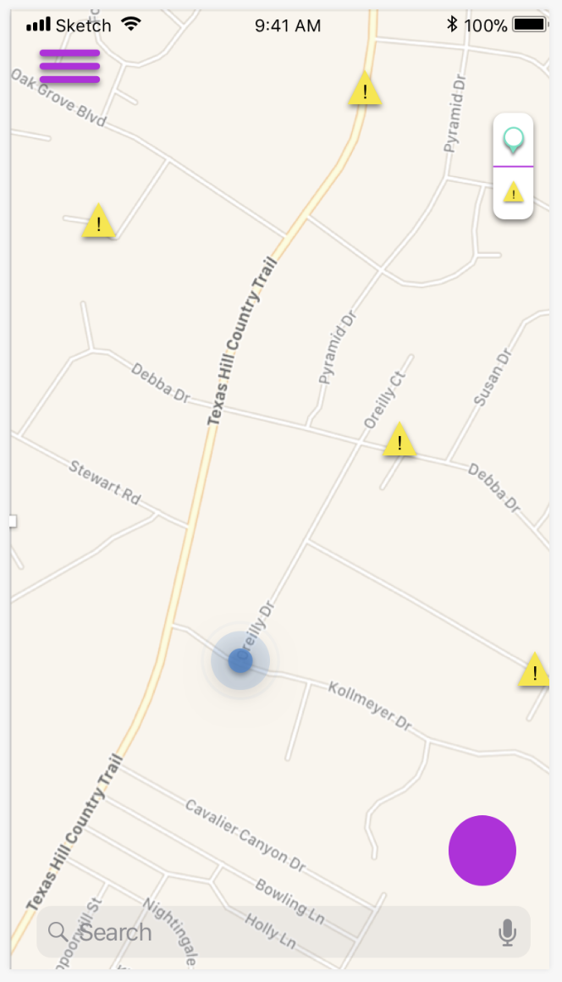

As an officer, I want to know what incidents are happening around me, where my fellow officers are located, and where my location is.

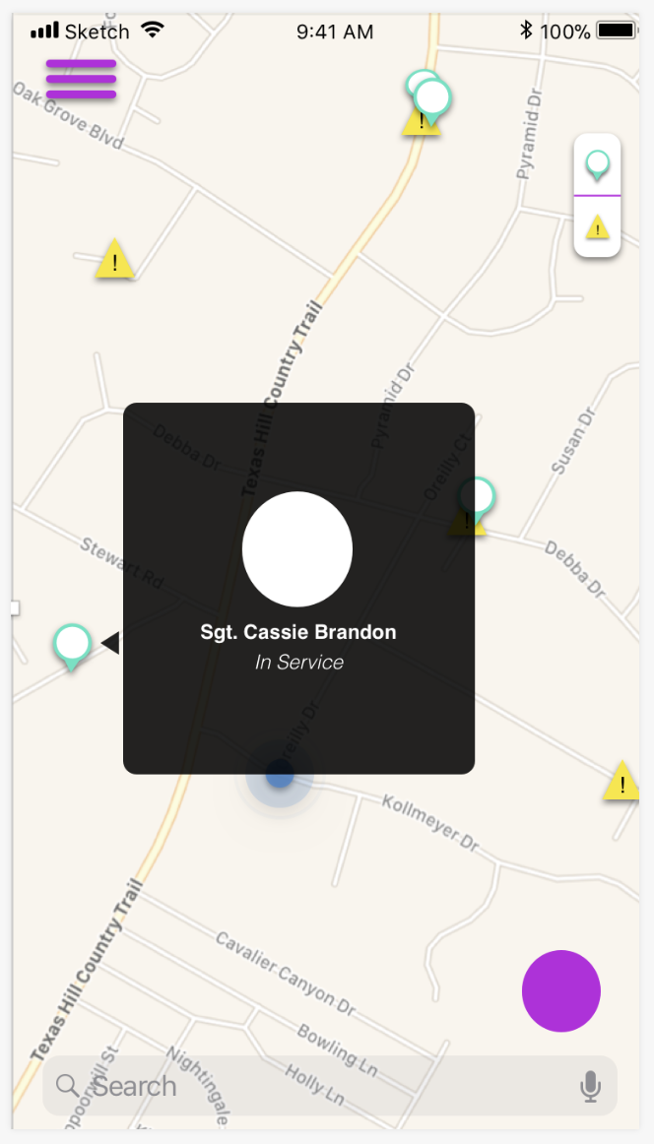 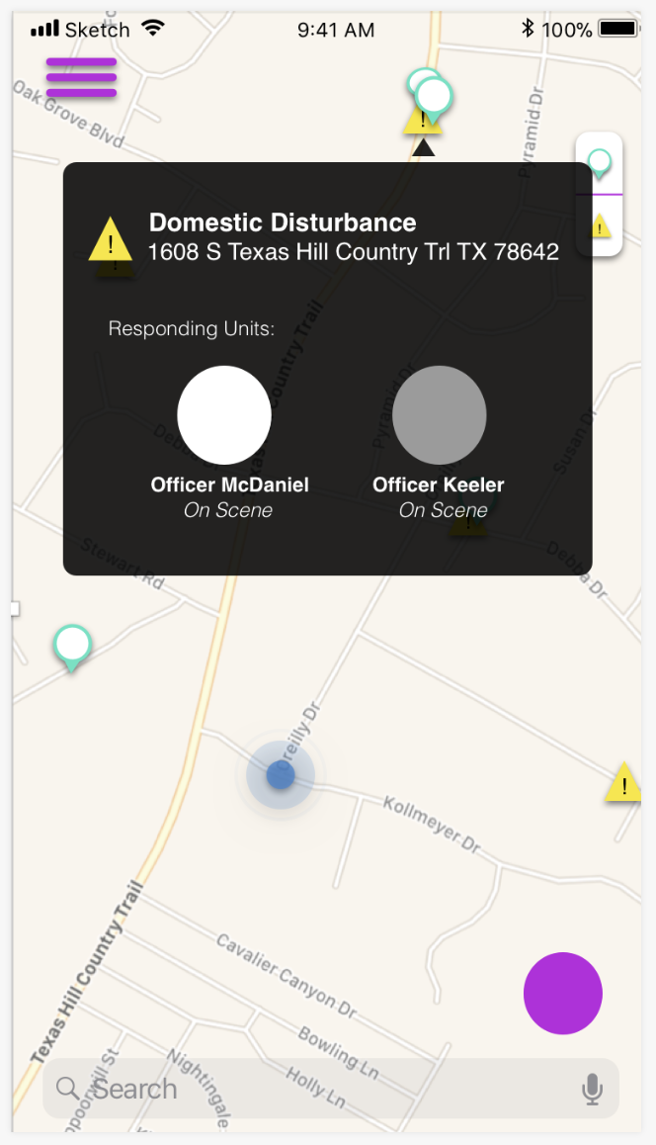

As an officer, I want the ability to see additional details regarding what is happening at a certain location, who my fellow officers are and when their status is.

EPIC#2 Status Change

*There are* ***three*** *different elements to a unit/officer’s status:*

1. *Binary Status*
2. *Unit Status*
3. *Call Status*

BINARY STATUS:

The binary status indicates whether the officer is currently *‘on the clock’* (working, on duty) or *not* (not working, off duty).

**Status Options:**

1. ON DUTY
2. OFF DUTY

**Please note the following:**

* *An officer can open and work within the application and* ***NOT*** *be ON DUTY, he will be labeled as OFF DUTY.*
* *An officer has to mark himself as ON DUTY or OFF DUTY. This status is not assumed when he opens the application.*
* *Because an officer is labeled as ON DUTY, that does NOT mean that he is available for dispatch.*

UNIT STATUS:

The unit status essentially has two layers that ascertain the following information;

1. Is the officer available for dispatch.
2. Where is the officer / What is he doing

An officer can be at a certain location and be either *available* **or** *unavailable* for dispatch, based on what he is doing.

So, we need to create an opportunity for the officer to easily communicate where he is and whether, or whether not, he is available to be dispatched.

**We need to create a visual indicator on the Main Map Display for the officer to be aware of what his current status is set to AND give him the ability to change it easily.**

CALL STATUS:

An officer’s UNIT STATUS can change based on his interaction with a dispatch/call. This set of status’ that are directly tied to an incident (call, dispatch) is called a CALL STATUS.

When the officer has a new dispatch and is driving to the incident, his UNIT STATUS should automatically change to the CALL STATUS **ENROUTE**.

When the officer has arrived, his UNIT STATUS should change to ON SCENE.

**Status Options:**

1. Enroute
2. On Scene

These status changes are the **only** ones that should be changed behind the scene for the officer, so he SHOULD NOT have to change the status himself.

There is a 3rd CALL STATUS option that the officer can select himself. That is when he is transporting a person to jail. In the call notes, he can enter a person and then select **Transporting**. This will change his status.

1. Transporting

EPIC#3 NEW DISPATCH

As an officer, I want to be notified when I am assigned a new dispatch with the necessary information to do my job to the best of my ability.

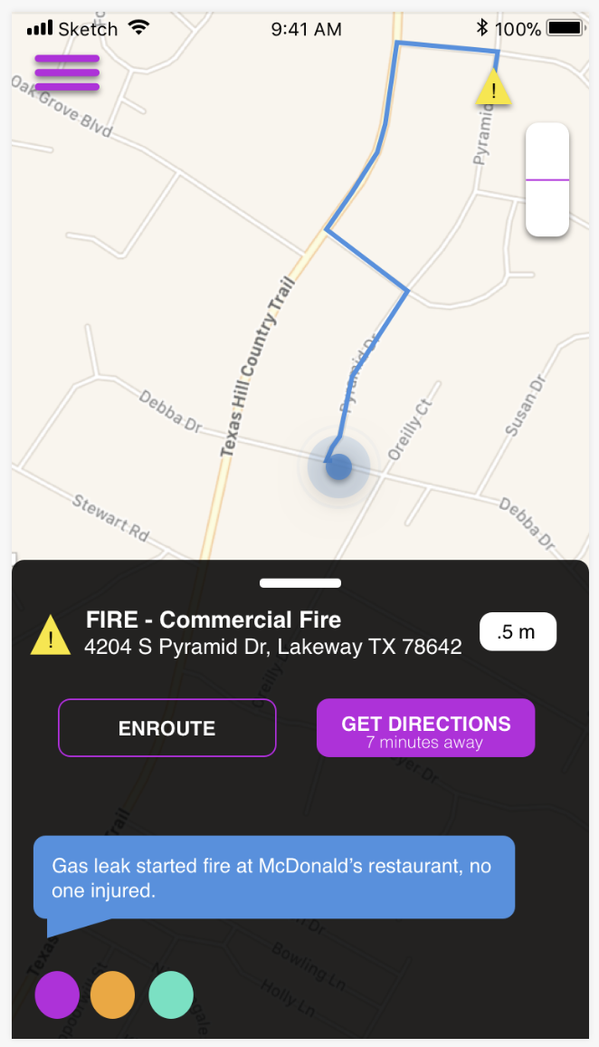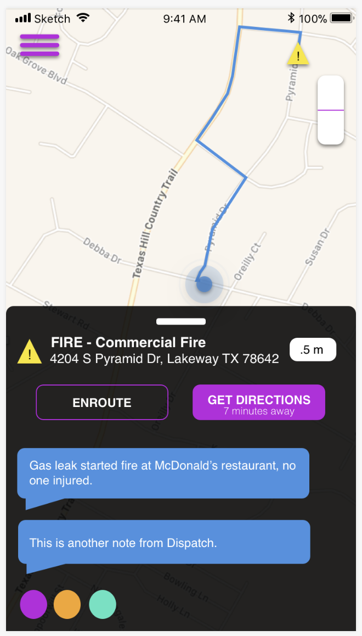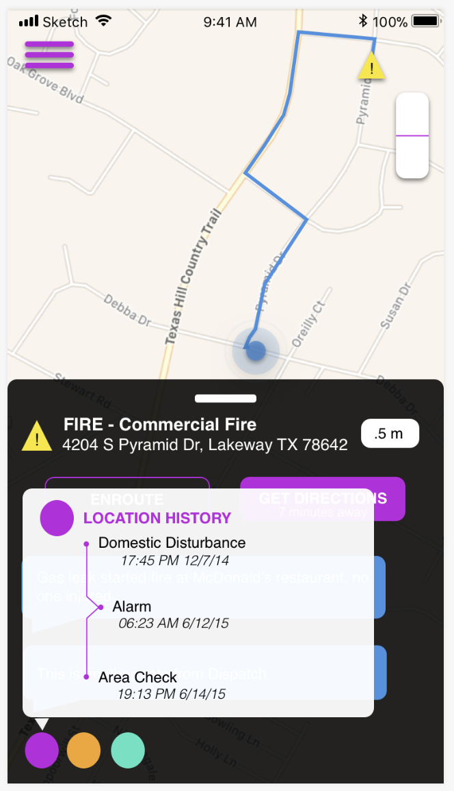

Elements of a New Dispatch:

*Map Display:*

* My Location
* Call Location
* Best Route

*Information Bar:*

* Call Type
* Call Priority
* Call Address
* Distance away in Miles
* Time away in current traffic
* Dispatch Communication
* Location History (Displayed only if applicable)

*Options for Action:*

* Enroute
* Get Directions

EPIC#4 On Scene Info Gather

We want to provide a free-flowing creative space for an officer to take notes and enter information without defined process ( so the officer can use the application in the specific way that he works)

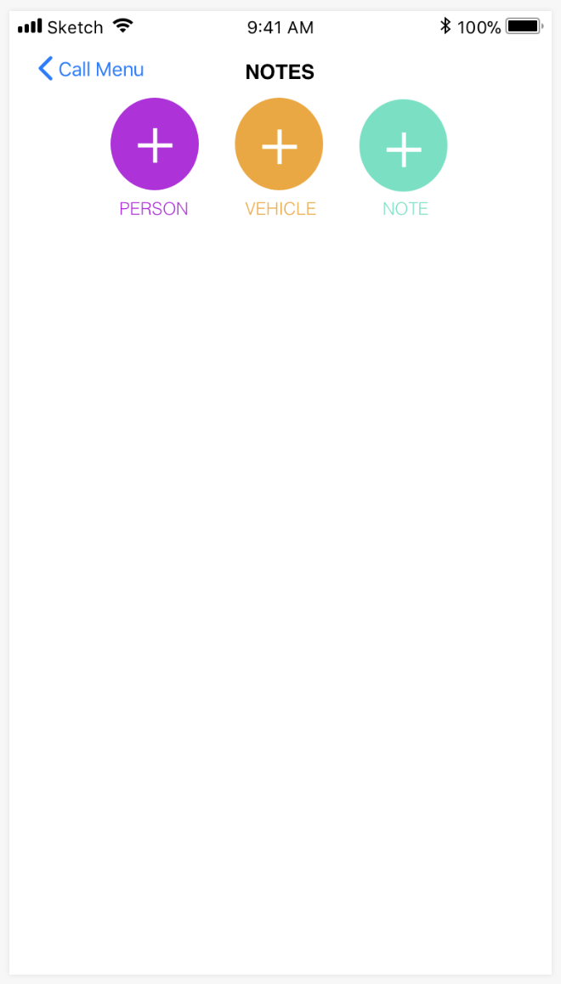 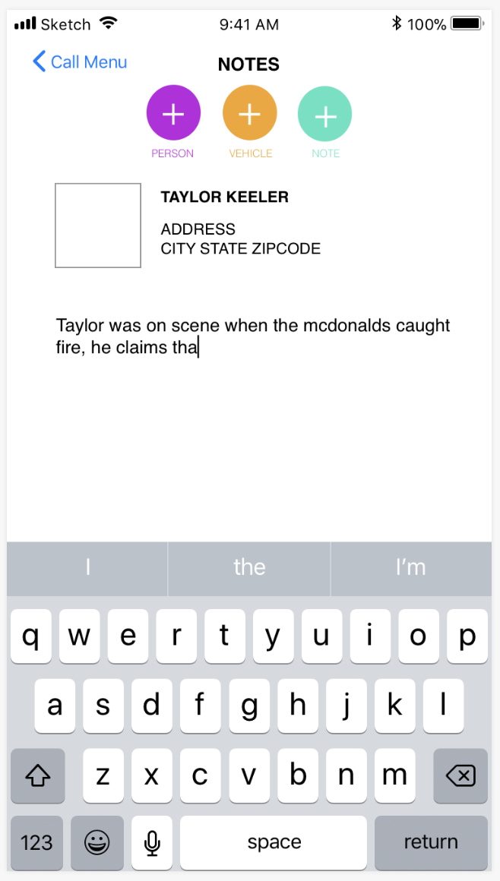

We want the officer to have an easy to access and very clear visual of all details of the call.

